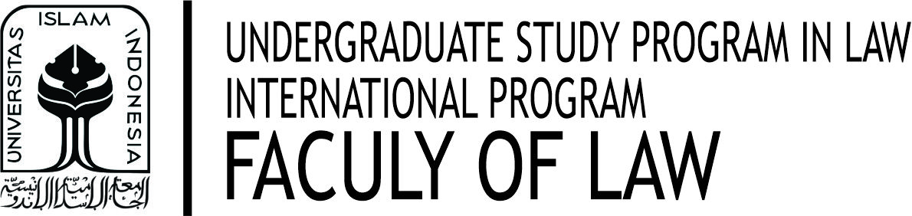 |  |  | MID EXAM ANSWER SHEET (UTS)  ODD SEMESTER 2020/2021
Student No. | : |  | Student Name | :
Subject | : |  | Exam Date | :
Class | : |  | Exam Starting Time | : | …… . …… (Indonesian Western Time)
Lecturer | : |  | Exam Finished Time | : | …… . …… (Indonesian Western Time)
